

**Lab # 06**

**Student Name: Piyar Ali Soomro**

**Roll Number: BIT-23F-019**

**Section: A**

**Subject: Artificial Intelligence**

**Department: BS Information Technology**

**New assignment:**

**Lab: 06**

**Task: 01:**  
 Write a Python function that draws a square using asterisks (*). The side length of the square should be provided by the user.

**Code:**

def draw_square(side_length):

    if side_length < 1:

        print("Side length must be a positive integer.")

        return

    for _ in range(side_length):

        print("* " * side_length)

# Example usage

side_length = int(input("\n=> Piyar Ali Please Enter the side length of the square: "))

draw_square(side_length)

**Output:**

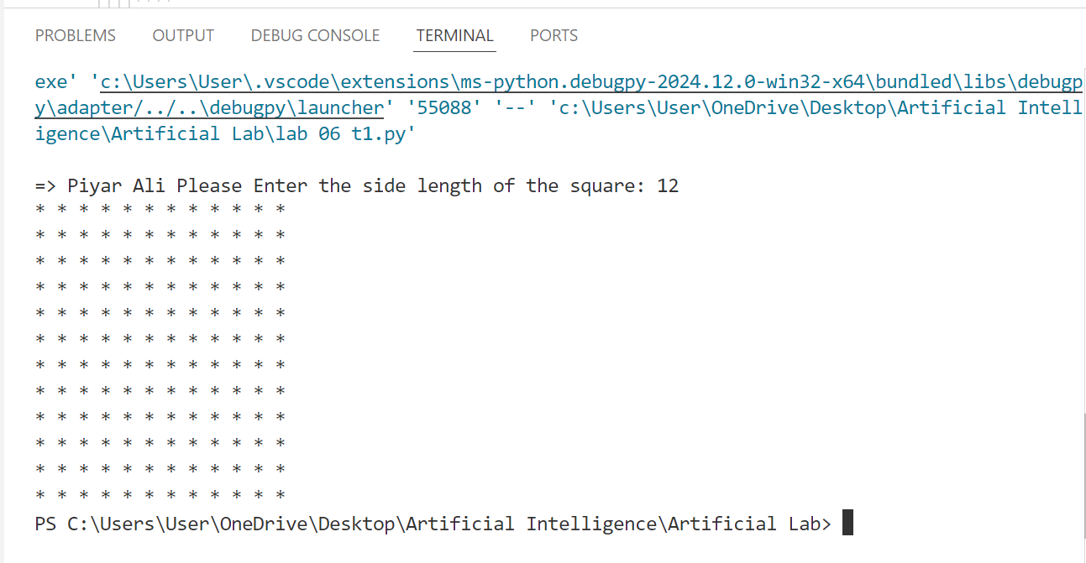

**Task: 02:**  
 Write a Python function that takes a list of numbers as input and returns the sum of only the even numbers.

**Code:**

def sum_of_evens(numbers):

    return sum(num for num in numbers if num % 2 == 0)

# Example usage

numbers = [1, 2, 3, 4, 5, 6 ,7, 8,9,10,11,12,13,14,15,16,17,18,19,20,21,22,23,24,25,26]

print("\n<__P__I__Y__A__R__^__A__L__I__S__>")

print(f"\n The sum of even numbers is : {sum_of_evens(numbers)}")

print("\n<~~~~~~~~~~~~~~~~~~~~~~~~~~~~~~~~>")

**Output:**

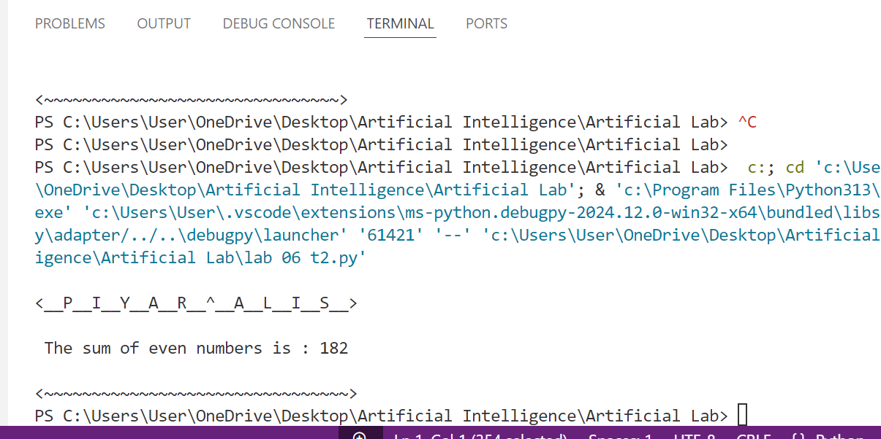

**Task: 03:**    
 Write a Python function that takes a number as input and counts down to zero, printing each number.

**Code:**

def countdown(number):

    if number < 0:

        print("Please provide a non-negative number.")

        return

    for i in range(number, -1, -1):

        print(i)

# Example usage

start_number = int(input("Enter a number to start the countdown: "))

countdown(start_number)

**Output:**

